Diffusion

- State the definition of diffusion.

The spreading of particles of a liquid or a gas resulting in net movement from an area of high concentration to an area of low concentration.

- State the definition of a concentration gradient.

The difference in concentration between an area of high concentration and an area of low concentration.

- Decide if the rate of diffusion would be increased or decreased by making the following changes:

- Decreasing the temperature decrease
- Increasing the temperature increase
- Increasing the surface area increase
- Decreasing the surface area decrease
- Increasing the concentration gradient increase
- Decreasing the concentration gradient decrease

- On to each of the diagrams below draw an arrow to indicate the direction of net movement of particles. Explain your answer using the terms high concentration and low concentration.

Particles moving from high concentration to low concentration

Particles moving from HC to LC

Particles moving from HC to LC

No net movement as there is no
concentration gradient

e. Which of the above diagrams would have the fastest rate of diffusion and which would have the slowest? Explain your answer.

Fastest – A, because it has the greatest concentration gradient
Slowest – D, no concentration gradient

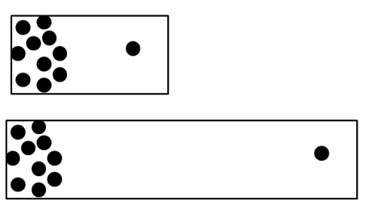
- Which of these would have a faster rate of diffusion? Explain your answer.
A

B

A would diffuse faster as the particles have a shorter path to travel, therefore they would be fully spread out and remove the concentration gradient faster.

- Using your knowledge of particle theory explain why the rate of diffusion would be increased by increasing the temperature.

Increasing the temperature increases the kinetic energy that particles have, therefore they move around faster with more energy. Diffusion is the movement of particles so if the particles are moving faster, diffusion will happen faster.

- Using your knowledge of particle theory explain why diffusion cannot happen in solids.

Diffusion involves the movement of particles. Particles in a solid are held in a fixed arrangement/lattice and are not free to move, meaning they cannot diffuse.

- Root hair cells are more effective at absorbing water than other types of plant cell. Explain why this is, using your knowledge of the structure of plant cells and root hair cells.

Root hair cells have a much greater surface area than other plant cells because of their long structure. This greater surface area allows diffusion to happen faster so more water can be absorbed through the root hair cells.

Stretch activity:

A scientist is trying to set a world record for the fastest rate of diffusion. Describe all the conditions that would be needed to allow this to happen.

- Highest possible temperature
- Greatest concentration gradient – useful to have a part of the fluid with a concentration of 0.
- Greatest possible surface area/large surface area to volume ratio.

